**Difference Between Windows and Document Object**

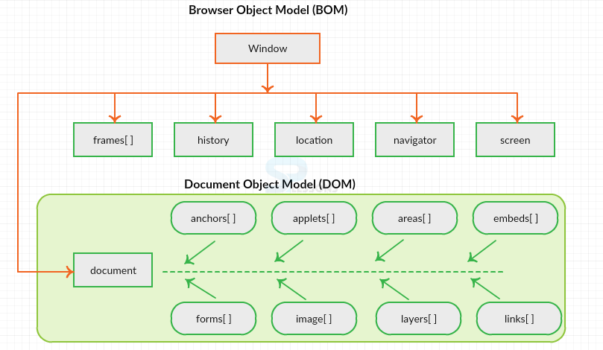

**Figure 1: Hierarchy of Window and Document object using BOM and DOM**

|  |  |
| --- | --- |
| **WINDOWS** | **OBJECT** |
| It is the top most object and outermost element of the object hierarchy | Each HTML document that gets loaded into a window becomes a document object. |
| It represents a browser window or frame that displays the contents of the webpage | The document object can be accessed with a window.document or just document. |
| Whenever a window appears on the screen to display the contents of the document, the window object is created | Using document object, JavaScript can modify, add and delete the HTML elements, attributes CSS styles in the page |
| **Syntax**: window.property_name; | **Syntax**: document.property_name; |
| It has different properties and methods | It has different properties and methods |
| ***window.open()*** opens a new tab or window | ***document.open()*** creates a blank document within the window. |